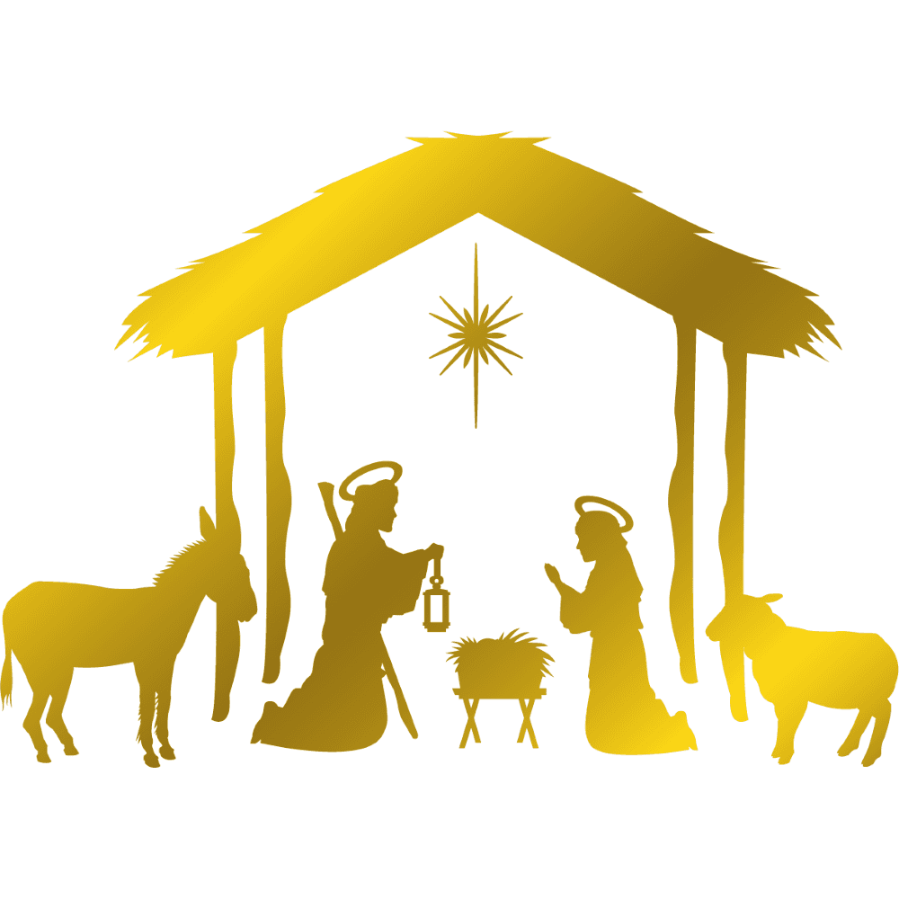
Join us here at
St Hilda’s Church

for Socially Distanced
Community Carol Singing
for all ages

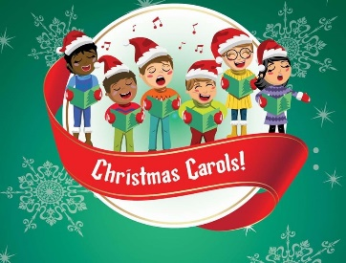
Saturday 19th December
at 2pm

Wrap up warm and bring hot drinks for a little bit of Christmas cheer

